***7/3/25***

***Day 5***

**Apply Styling**

* Style the header and footer using the AEM Style System.
* Update CSS in the ui.frontend module.

HEADER

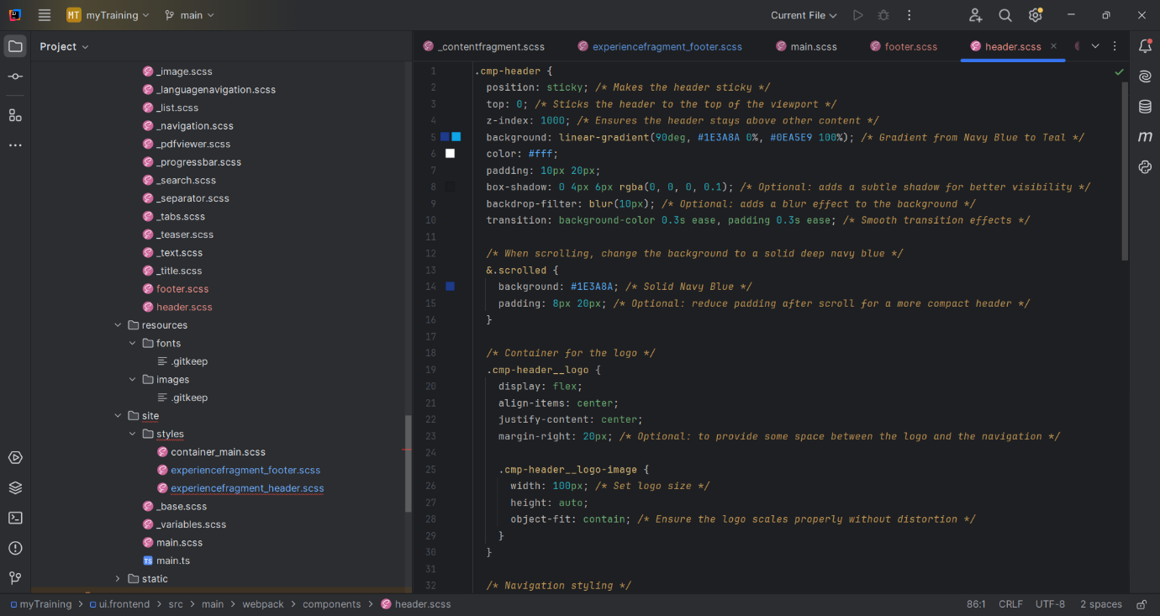

FOOTER

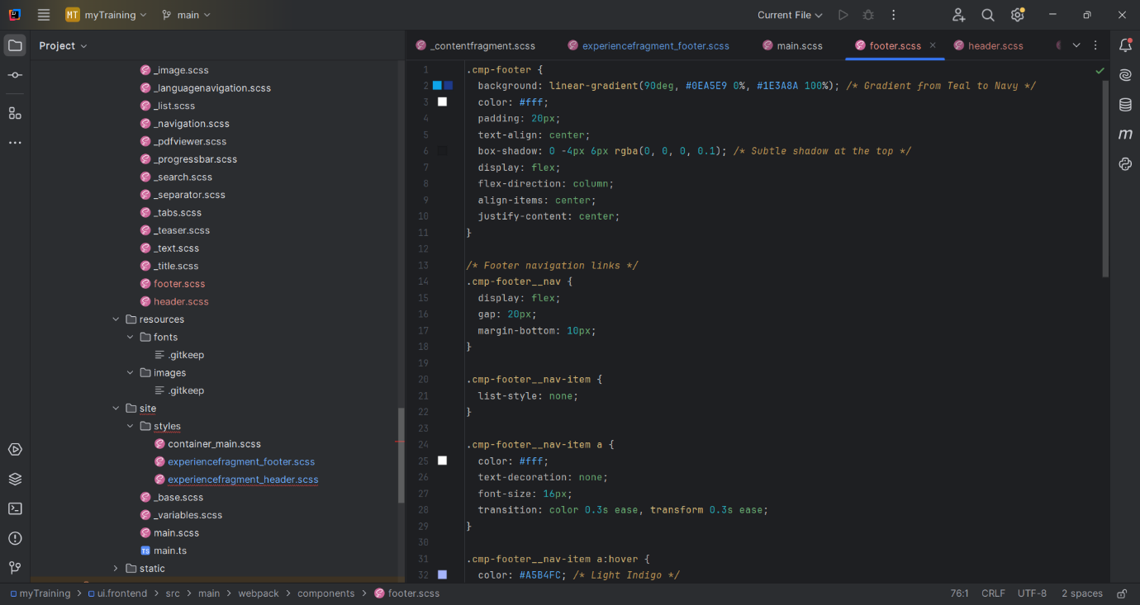

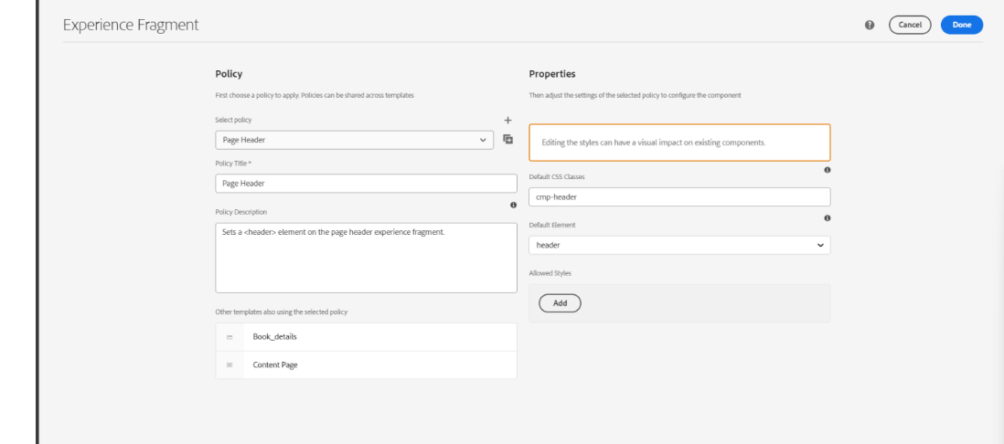

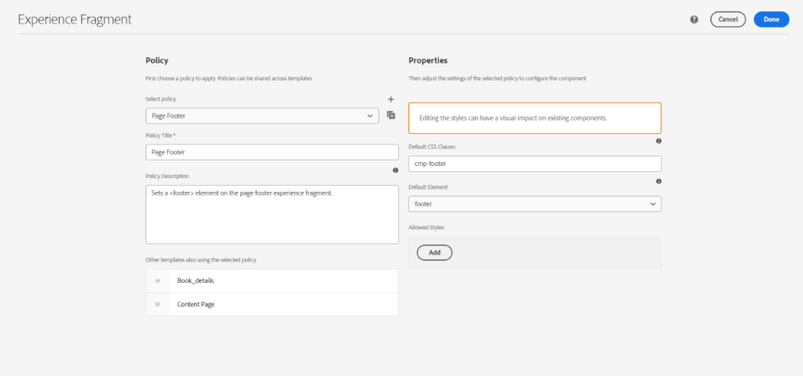

**HEADER FOOTER STYLING**

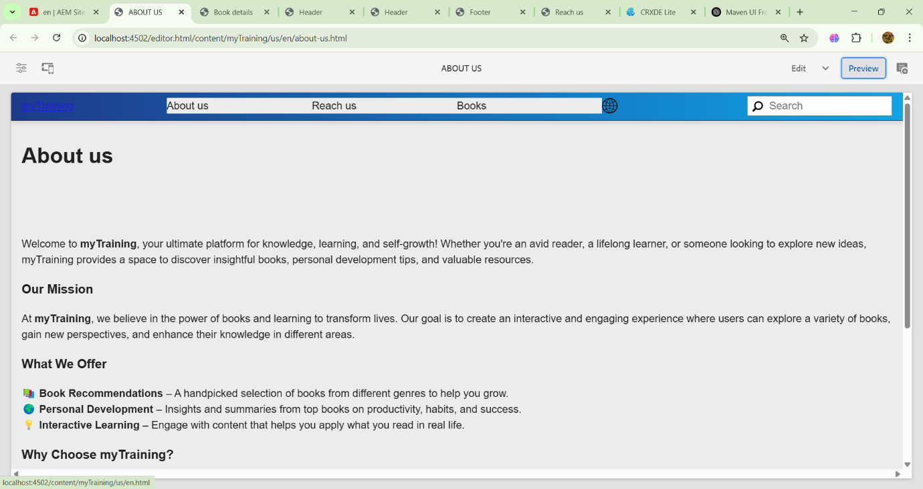

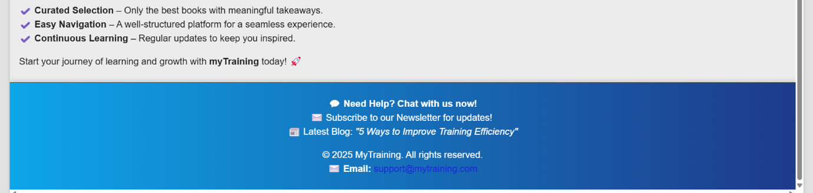

**Custom Page Property**

A new textarea property, **'addScript'**, has been introduced in the Book Page component, enabling authors to dynamically inject scripts.

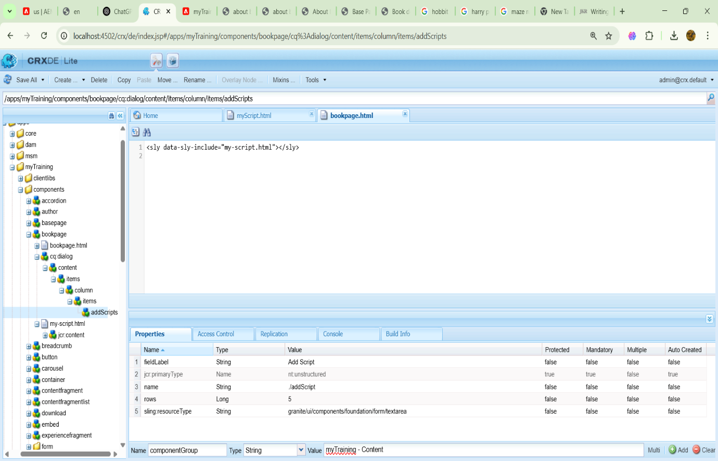

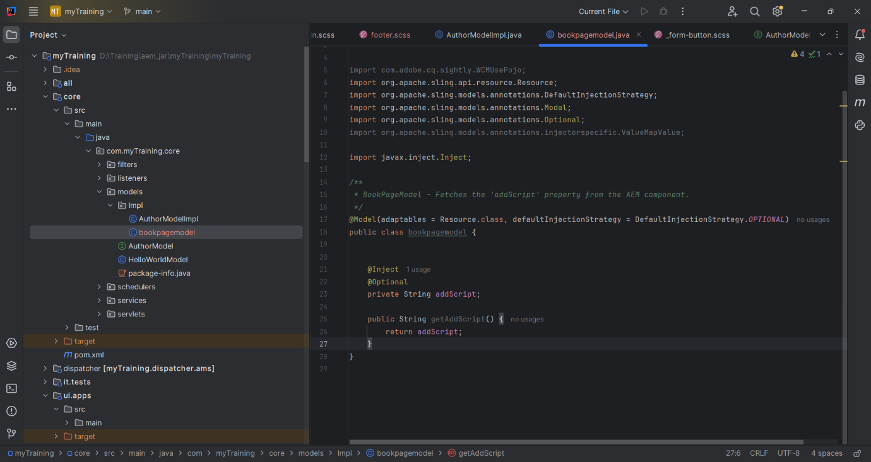

**Enhancements to the Author Component:**  
A new text property and a multifield for books have been introduced in the Author component. A Sling model has also been implemented to fetch these properties.

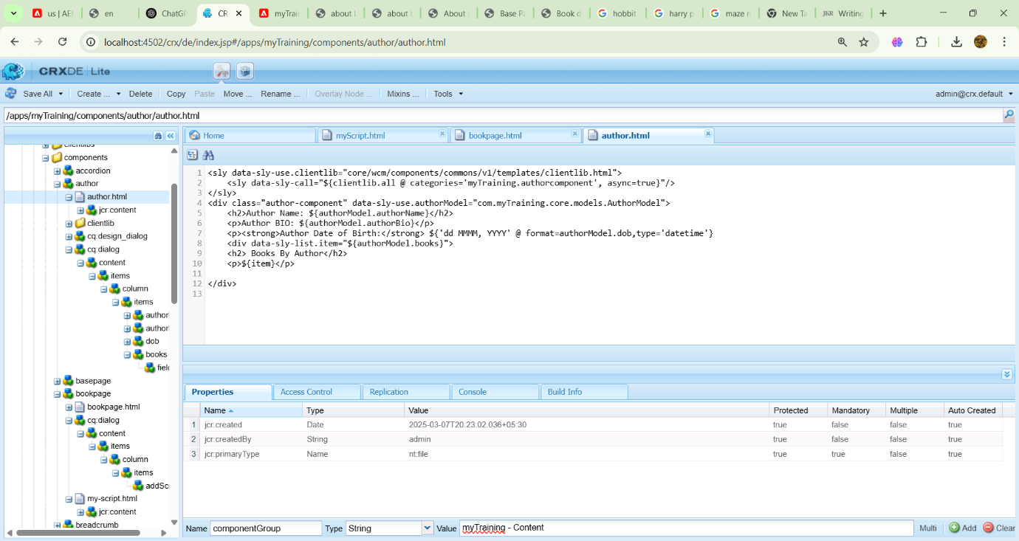

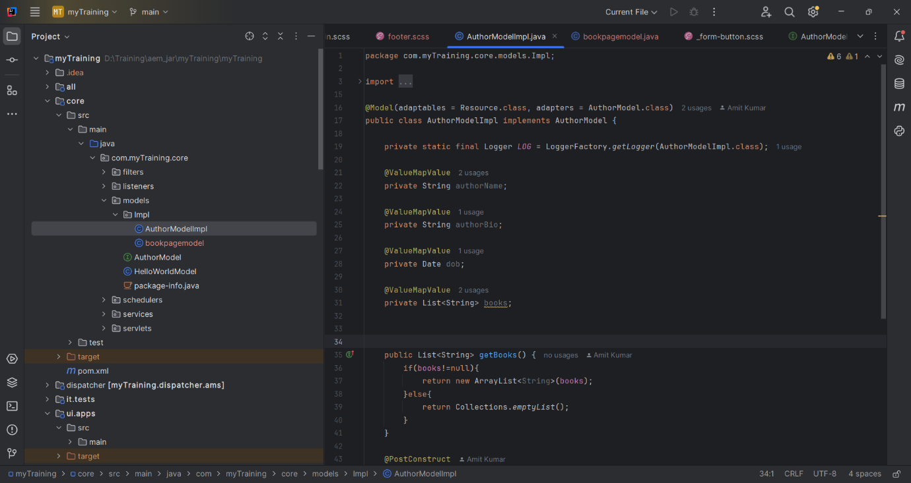

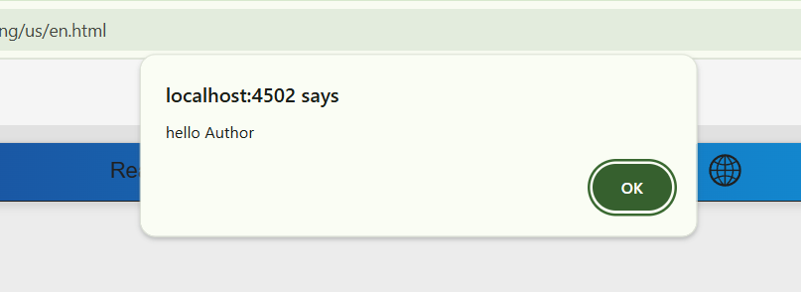

Author Details Component implemented by multifield

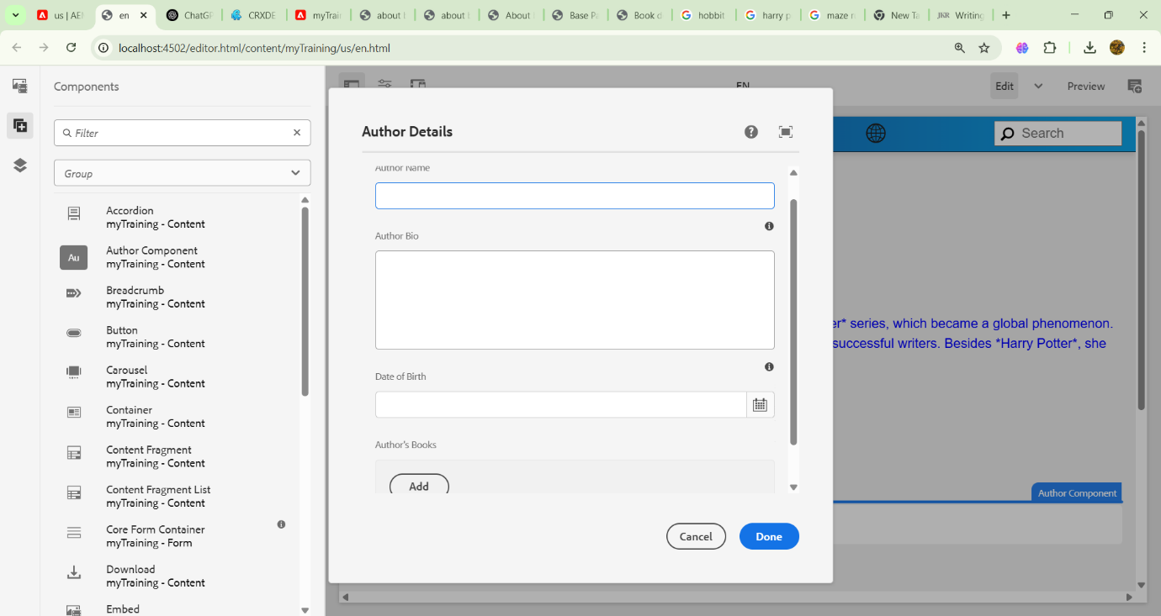

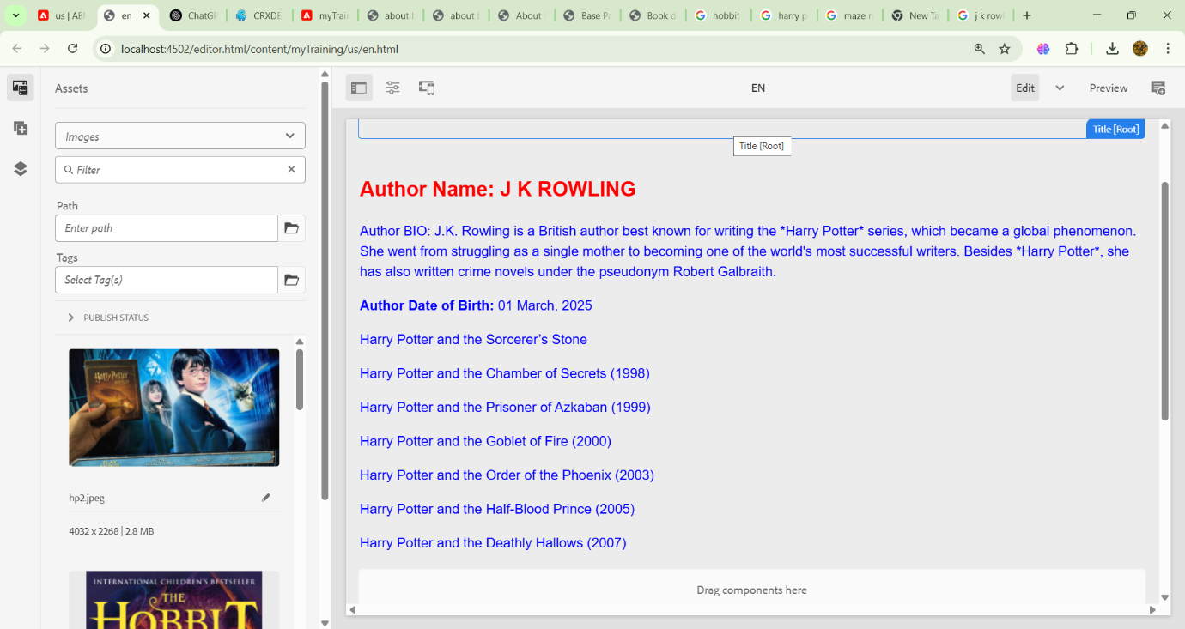

**Development of 'About Book' Template:**  
A new template, built upon the base page template, has been created to help authors efficiently generate book-related pages.

